# Docker - Continuous Integration

Docker has integrations with many Continuous Integration tools, which also includes the popular CI tool known as **Jenkins**. Within Jenkins, you have plugins available which can be used to work with containers. So let’s quickly look at a Docker plugin available for the Jenkins tool.

Let’s go step by step and see what’s available in Jenkins for Docker containers.

**Step 1** − Go to your Jenkins dashboard and click **Manage Jenkins**.

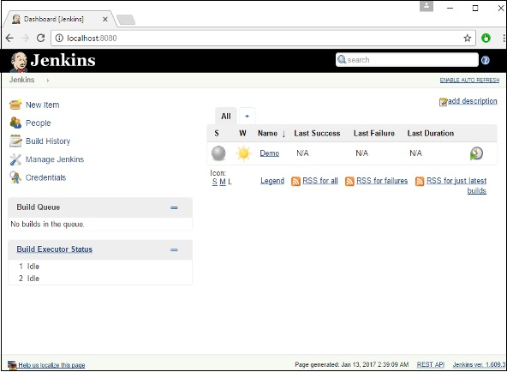

**Step 2** − Go to **Manage Plugins**.

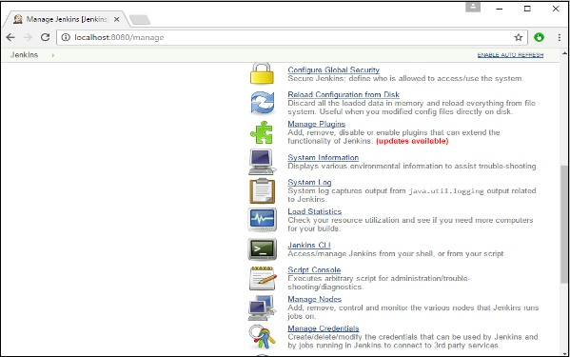

**Step 3** − Search for Docker plugins. Choose the Docker plugin and click the **Install** **without restart** button.

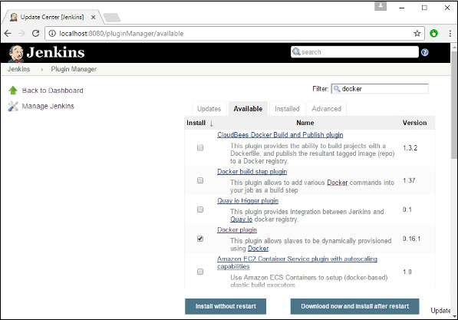

**Step 4** − Once the installation is completed, go to your job in the Jenkins dashboard. In our example, we have a job called **Demo**.

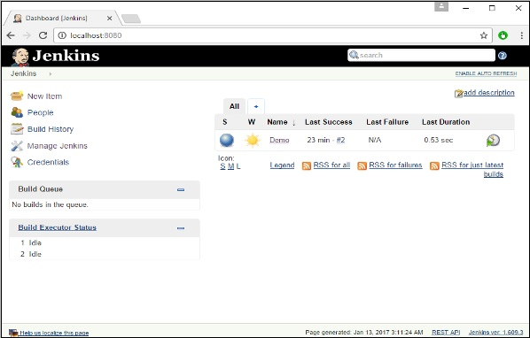

**Step 5** − In the job, when you go to the Build step, you can now see the option to start and stop containers.

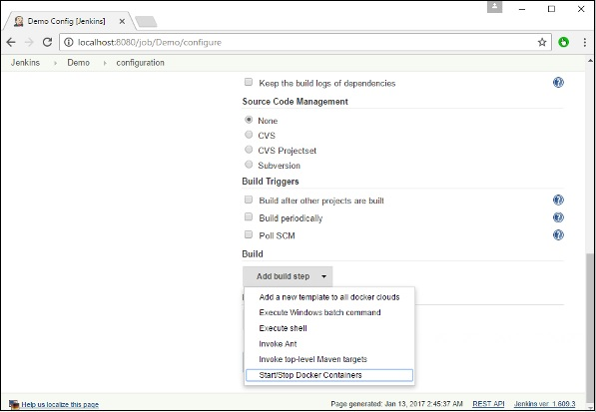

**Step 6** − As a simple example, you can choose the further option to stop containers when the build is completed. Then, click the **Save** button.

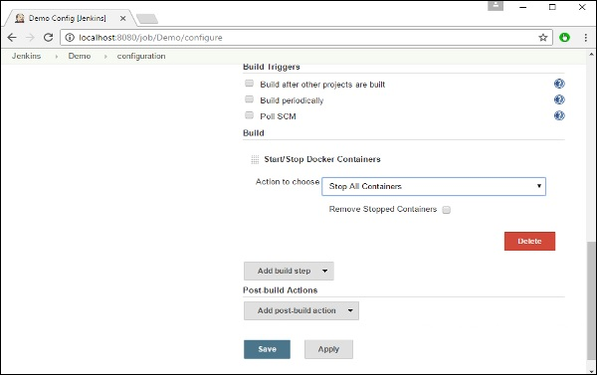

Now, just run your job in Jenkins. In the Console output, you will now be able to see that the command to Stop All containers has run.

